The government still doesn't know how many nursing homes have coronavirus outbreaks
The lag in data collection is just one of a number of bottlenecks in the effort to slow the virus' deadly spread in nursing homes across the U.S.

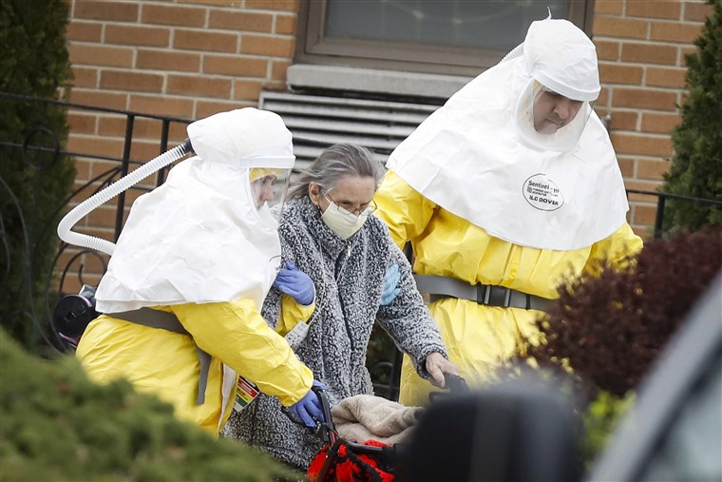

Medical workers help a resident of St. Joseph's Senior Home in Woodbridge, N.J., board a bus on March 25, 2020, after a number of residents tested positive for the coronavirus. Stefan Jeremiah / Reuters

May 8, 2020
By Laura Strickler and Suzy Khimm
WASHINGTON — On April 19, Medicare Administrator Seema Verma took the podium at the White House's daily coronavirus briefing to announce that the Trump administration would begin tracking outbreaks and deaths at long-term care facilities nationwide — and publish the numbers for everyone to see.
The effort would begin within days, federal officials promised.
More than two weeks and 13,000 long-term care deaths later, the federal government still has not tallied the number of nursing homes that have had outbreaks nationwide or the number of residents who have died. And the data is still weeks away from being made public, according to the Centers for Medicare and Medicaid Services, or CMS, the federal agency that oversees nursing homes.
The delay in data collection is one of a number of bottlenecks in the effort to slow the virus' deadly spread in nursing homes across the U.S., hampering officials' ability to target hot spots and send additional resources where they are needed, according to public health experts. The administration has also been slow to send supplies of personal protective equipment, or PPE, to long-term care facilities, and it delayed a requirement that nursing homes report coronavirus outbreaks to family members. A requirement that families be notified of outbreaks was approved on April 19 but didn't go into effect until Friday.
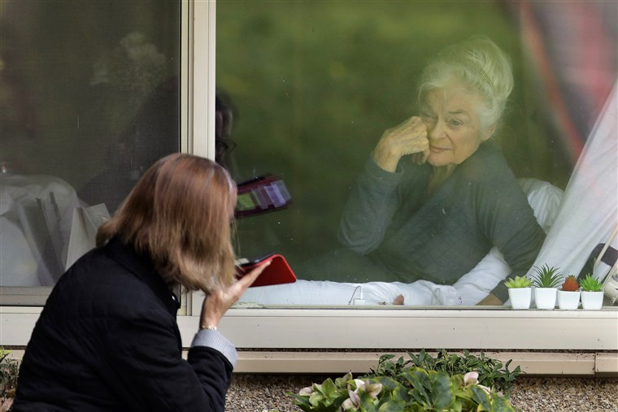
Lori Spencer visits through the window and on the phone with her mother, Judie Shape, who tested positive for the coronavirus, at Life Care Center in Kirkland, Wash., on March 17, 2020.Ted S. Warren / AP file
"We think there is huge under-identification of the virus in nursing homes, so until they start reporting and comprehensive testing, it's not going to work," said Charlene Harrington, a professor emerita of nursing at the University of California San Francisco. "I think the problem is CMS and the governors have not put the nursing homes at the top of the list — and I can't think of any group that is more vulnerable."
A spokesperson for CMS defended the agency's data collection efforts in a statement to NBC News.
"As nursing homes report this data to the [Centers for Disease Control and Prevention], we will be taking swift action and publicly posting this information so all Americans have access to accurate and timely information on COVID-19 in nursing homes. This reporting requirement is the first action of its kind in the agency's history," the statement read. "The agency remains committed to greater transparency, and will never stop working to give patients, residents, and families the clearest and most accurate information possible."
The nursing home industry says knowing the scope of the problem and which facilities should get priority is crucial. The need for greater access to testing and protective equipment has become even more urgent as more states are beginning to ease restrictions and reopen, effectively leaving older Americans "to fend for themselves as the virus threatens to wipe out an entire generation," LeadingAge, which represents nonprofit long-term care facilities, said in a statement.
David Grabowski, a professor of health policy at Harvard Medical School, said: "There's no way to actually get ahead of this if we don't have any data — it tells us where we have a problem. We know nothing about these facilities in terms of their personal protective equipment or in terms of their staffing or their infection control capability."
The CDC launched a tool this week for nursing homes to report the number of suspected and confirmed COVID-19 cases and deaths, supplies of personal protective equipment and hand hygiene materials, staffing levels and access to testing, according to CMS.
But the new federal reporting requirements aren't scheduled to go into effect until Friday, and CMS said the data about individual facilities willn't be publicly posted until the end of May, according to a memo sent to state officials Wednesday.
From the early weeks of the pandemic, the Trump administration has stressed the need for states, not the federal government, to take the lead, while key federal agencies have taken a back seat. The decentralized approach has long been the case for nursing home oversight: While the federal government has legal oversight over nursing homes, which receive taxpayer dollars through Medicare and Medicaid, federal officials rely on states to conduct routine surveys and collect data on facilities.
As the pandemic rampaged through nursing homes, the need for comprehensive, national tracking of cases became clear, and there were discussions at the CDC about whether to collect the data as early as the first week of April.
But federal agencies spent weeks trying to decide who should take the lead, said Tricia Neuman, senior vice president of the Kaiser Family Foundation.
"This was not something in their wheelhouse — they couldn't just turn on the lights and fix the problem," Neuman said. "There was this delay in determining whose job it was to fix" it.
Alice Bonner, who was director of CMS' nursing home division during the administration of President Barack Obama, acknowledged the lingering questions about the slow response.
"All I can say is we have heard those questions — everyone — they are all wondering the same thing," said Bonner, who suggested that the delays may stem, in part, from the different ways states collect data.
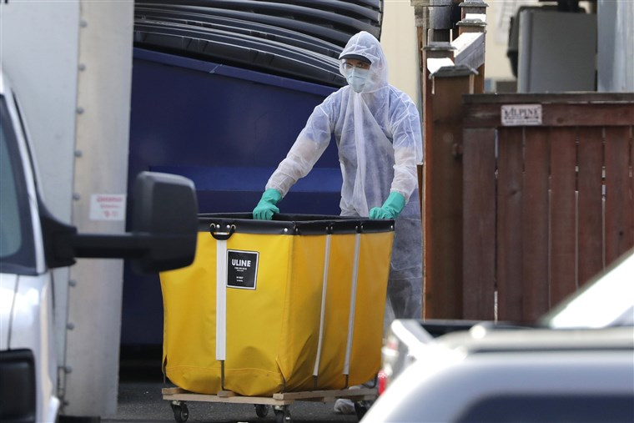

A member of a cleaning crew wheels a cart toward a vehicle at Life Care Center of Kirkland, Wash., on March 18, 2020.Elaine Thompson / AP file
Under the new requirements, long-term care facilities must begin reporting coronavirus cases and other data to the federal government by May 17 or face monetary penalties. However, they will initially have a two-week grace period to comply, according to CMS.
Nursing homes around the country are already required to report coronavirus cases to local and state health authorities.
As nursing home infections and deaths have risen, Democrats in Congress have become increasingly critical of the Trump administration's limited efforts to aid long-term care facilities, describing a sluggish response that is putting some of the country's most vulnerable residents in jeopardy.
"This administration's response to the COVID-19 crisis in America's nursing homes has been wholly inadequate," Sens. Ron Wyden, D-Ore., and Bob Casey, D-Pa., said in a joint statement. "We have been calling for more than a month for infection and death data to be made available."
Some Republicans have also conceded that officials' effort to contain the virus' spread in the country's nursing homes has fallen short.
"All along I've said the approach should've been more targeted and selective at places most vulnerable," Sen. Mike Braun, R-Ind., said Wednesday on MSNBC. "Whether you marshal those efforts through the federal government or the nursing home entities themselves or the state governments, we should've done a much better job at protecting those most vulnerable."
The lack of comprehensive federal data has obscured the true toll the virus is taking on nursing homes and their residents, given the huge discrepancies in state-level tracking efforts.
As of this week, more than 19,000 coronavirus deaths have been associated with long-term care facilities, according to data from 42 states collected by NBC News. That represents at least a quarter of all known coronavirus deaths, but it is likely to be a significant undercount, given the gaps in state-provided data. Seven states haven't responded to NBC News' requests for data on facility outbreaks, and nine haven't responded with death data. Some states don't report nursing homes with small numbers of cases.
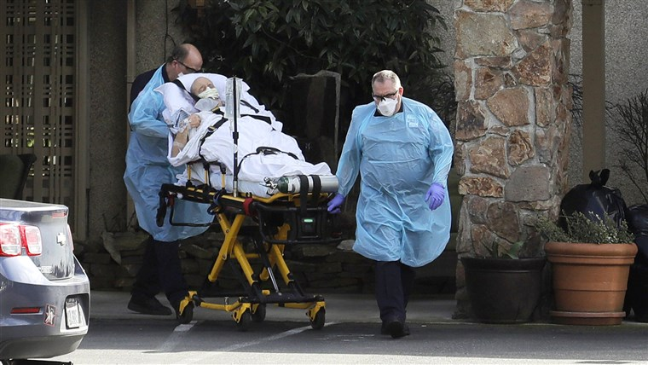

A person is carried toward an ambulance at Life Care Center of Kirkland, Wash.,
on March 12, 2020.Ted S. Warren / AP
The World Health Organization estimates that up to half of all coronavirus deaths in Europe have happened in nursing homes and other long-term care facilities. That is already the case in Massachusetts, Oregon, Colorado and a handful of other states, according to a recent analysis by the Kaiser Family Foundation.
In Florida, news organizations had to sue to get access to information specific to nursing homes. In New York, because of a new reporting system, the state attributed an additional 1,700 nursing home COVID-19 deaths to its tally this week. In Michigan, where the virus has rampaged through 486 nursing homes, the state has yet to release any data on deaths. Missouri told NBC News that it isn't tracking those deaths at all.
Nursing home administrators have also made urgent pleas for personal protective gear and universal, regular testing, which Maryland, West Virginia and two other states have made mandatory. "Our leaders did not plan, did not listen, and did not prioritize the lives of older Americans," said Kate Smith Sloan, president and CEO of LeadingAge.
The federal government has yet to step in to fill the critical gap, and many states have been unable to meet the needs on their own, according to advocates and industry groups.
"I would have a daily call with every nursing home operating in the country to identify those needs," said Andy Slavitt, who led CMS during the Obama administration. "The first time we hear about a nursing home shouldn't be when 50 people have died."
The White House announced April 30 that the Federal Emergency Management Agency would ship a seven-day supply of critical gloves and masks to nursing homes nationwide. But as of this week, FEMA says, just 5 percent of the shipments are out the door. The second seven-day shipment won't arrive until July.

An administrator who runs a nursing home with 700 residents in upstate New York told NBC News on Thursday that he was grateful for the large shipment of equipment he just got from FEMA — but he has no coronavirus cases in his facility.
The federal government needs to deliver on its promises for greater help, said Walter Ramos, president and CEO of Rogerson Communities, a Boston nonprofit that runs long-term care facilities.
"Reporting has to come with results," Ramos said. "I do need that reporting to mean something to the people we are reporting to — I need the rapid testing. I need the PPE."
According to a recent NBC News-Wall Street Journal poll, at least 19 percent of Americans are worried about "a family member in a nursing home or long-term care facility."
The Trump administration held a hastily arranged event for "senior citizens" at the White House on April 30. The president unveiled a commission on nursing home quality, but as of his announcement no members had been selected or announced. The contract to run the commission was awarded the same day its creation was announced.
Meanwhile, reports have emerged of questionable deaths from nursing homes. In some cases, outbreaks are alleged to have been hidden from families until it was too late.
On April 19, the federal government announced new requirements for all nursing homes to inform residents and their families about infections and outbreaks inside facilities. Current federal guidelines require nursing homes to inform only the relatives of individual patients who become infected, not all families.
Many families across the country are still in the dark: The family notification requirements aren't scheduled to go into effect until Friday, after weeks of pressure from resident advocates, legislators and state attorneys general.
"Unfortunately, not all nursing homes are communicating in real time the realities confronting some of our most vulnerable populations," California Attorney General Xavier Becerra said. "After issuing promising guidance to tackle this very issue, CMS has gone quiet, failing to issue any measures or rules to ensure its guidance has teeth."
Grabowski said the federal government should have stepped up months earlier, as the risks were clear from the very start: The first coronavirus outbreak in the U.S. began at a nursing home in Kirkland, Washington, with a case confirmed on Feb. 28.
"We let Kirkland happen, and we wasted that lesson," Grabowski said. "We continue to let nursing home outbreaks happen all across this country, and this problem has just grown and grown."

