PHOTOS: CELEBRATING MOTHER’S DAY, FROM A SOCIAL DISTANCE
UPDATED MAY 9, 2020, 5:32 P.M.
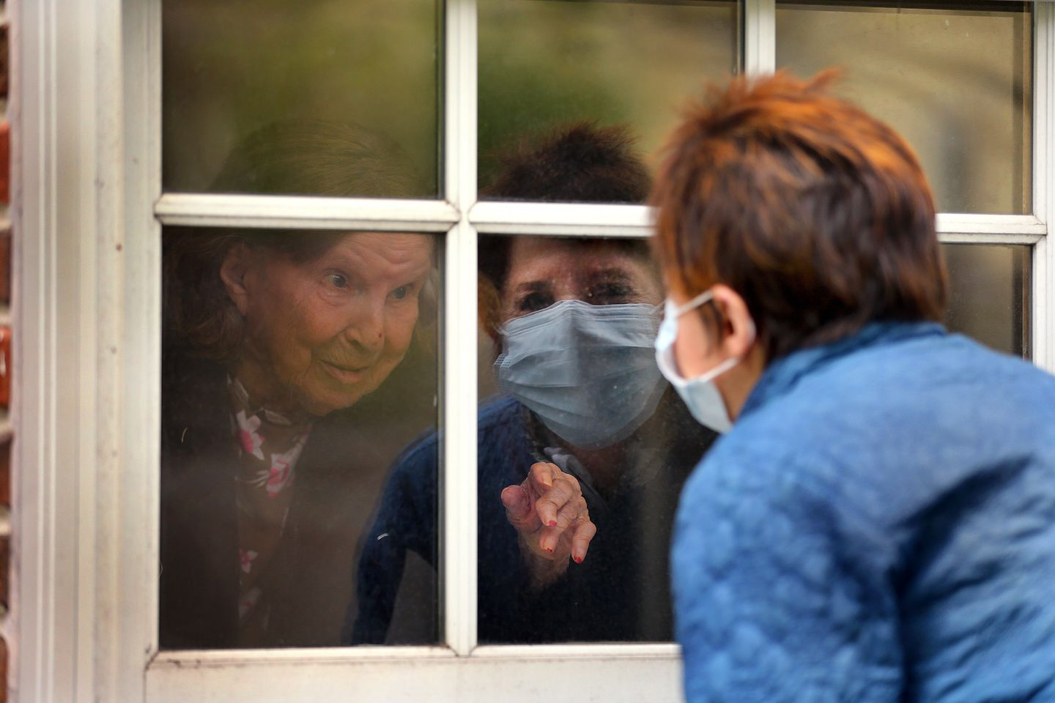ELLEN TAYLOR TALKED TO HER MOTHER, EVA TAYLOR, AGE 100, THROUGH HE FIRST FLOOR WINDOW OF BOSTON'S ROGERSON HOUSE.JOHN TLUMACKI/GLOBE STAFF

THE ROGERSON HOUSE ACCOMMODATED FAMILIES THAT WANTED TO VISIT THEIR MOTHERS AND GRANDMOTHERS FOR MOTHER’S DAY. DUE TO CORONAVIRUS RESTRICTIONS, FAMILY MEMBERS HAD TO STAY OUTSIDE.
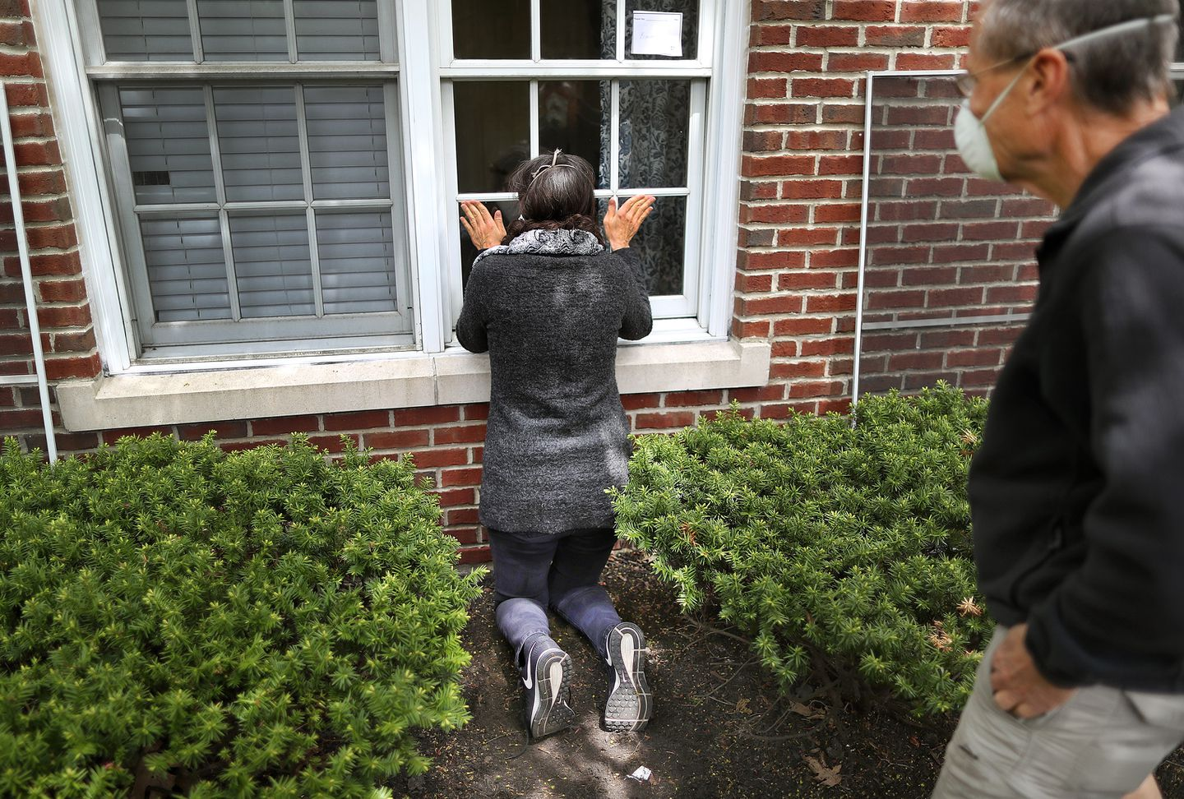SUSAN ADAMS KNEELED IN FRONT OF THE WINDOW OF HER MOTHER-IN-LAW, BARBARA ADAMS, AGE 96.JOHN TLUMACKI/GLOBE STAFF

ANDREA TAMKIN HELD A SIGN SHE MADE FOR HER MOTHER, RUTH TAMKIN AS HER HUSBAND JIM BOUCHARD HELD THEIR DOG ASTRO AND THEY SPOKE TO RUTH THROUGH HER SECOND-FLOOR WINDOW.JOHN TLUMACKI/GLOBE STAFF

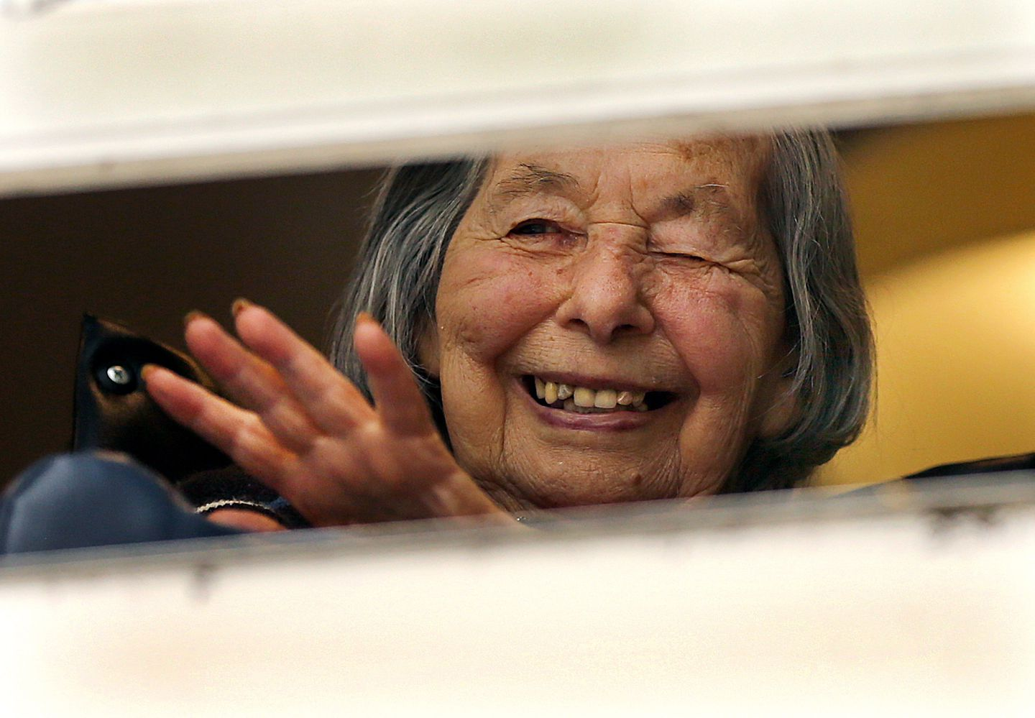RUTH TAMKIN WAVED FROM HER WINDOW.JOHN TLUMACKI/GLOBE STAFF

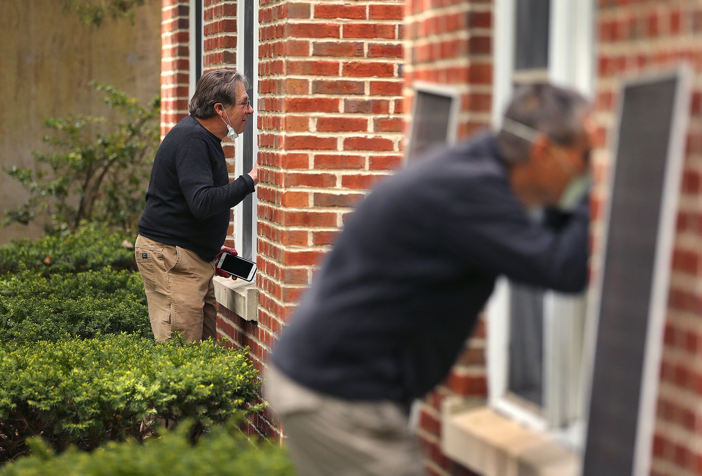PETER ZANE (LEFT) SPOKE THROUGH THE WINDOW TO HIS MOTHER, LILLIAN ZANE AGE 99, WHILE BRUCE ADAMS SPOKE TO HIS MOTHER, BARBARA ADAMS, AGE 96. JOHN TLUMACKI/GLOBE STAFF
LILLIAN ZANE, AGE 99, GOT EMOTIONAL AS SHE BLEW A KISS TO HER SON, PETER ZANE WHO WAS REFLECTED IN HER FIRST-FLOOR WINDOW. JOHN TLUMACKI/GLOBE STAFF

LYNN ST. AMOUR, LUIS PADRAZA, AND SON JOSEPH HELD MOTHERS DAY SIGNS AND FLOWERS FOR ESTHER PEDRAZA, 88. JOHN TLUMACKI/GLOBE STAFF

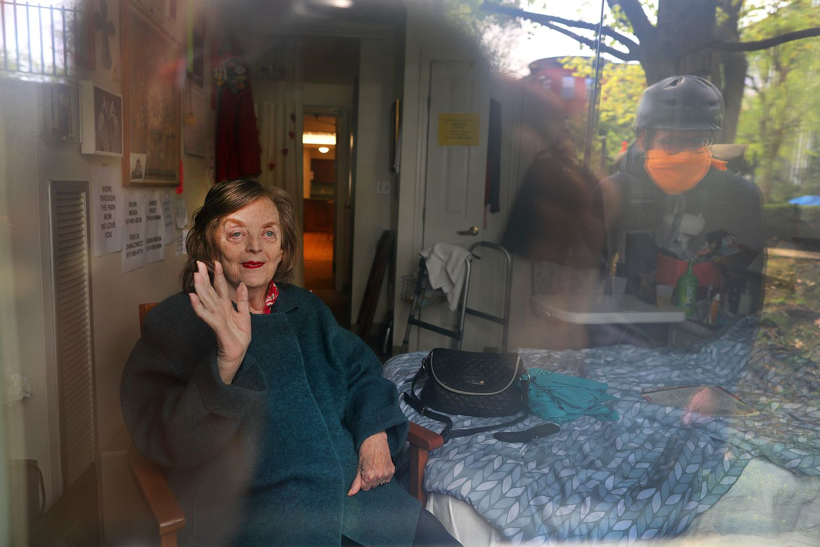KEVIN MICKA STOPPED BY ON HIS BICYCLE TO VISIT HIS MOTHER JOAN, AS HE WAS REFLECTED ON HER WINDOW ON THE FIRST FLOOR. JOHN TLUMACKI/GLOBE STAFF

